**Implementation of Layers for security protocols - SSL/TLS**

**Name:** Ayush Sharma

**Reg. No:** 15BCE1335

**Procedure:**

1. Download Sample SSL traffic capture file from wireshark wiki.
2. Include the SSL decryption key in Edit->Preferences->SSL->Key.
3. Check the decrypted https packets in the sample file.

**Screenshots:**

1. Captured Decrypted Https Packets

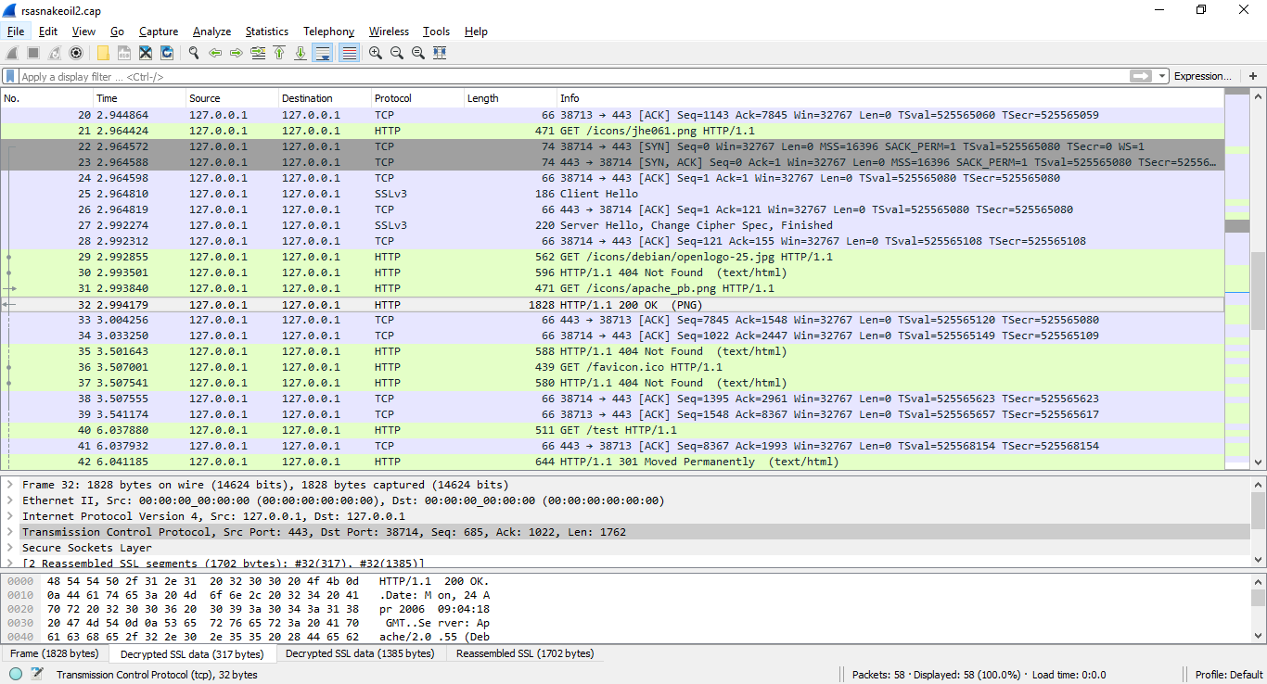

1. Single Decrypted Https Packet

